Refresh Dataset & Get Report List via Power BI Rest API using Python

Power BI REST API: What are they and how to use them?
Power BI's REST APIs facilitate integration, administration, and governance. By providing programmatic access to datasets and reports, these APIs allow you to go beyond the standard functionality of the Microsoft Business Intelligence platform. Explore how these tools can help you push the limits of what Power BI can do. You can use the Power BI REST API to integrate your current systems, automate various tasks, and easily embed reports into custom applications to improve reporting efficiency. In this article, we'll discover how to integrate APIs into Power BI, how to call a Power BI REST API from Python, and what's the difference between Power BI and REST API.
Power BI REST APIs: What are they?
An API, or Application Programming Interface, acts as a software intermediary that allows two applications to communicate with each other. Essentially, it facilitates the exchange and retrieval of information without requiring users to interact with the underlying technical details.
The acronym REST stands for Representational State Transfer. Consequently, a REST API is a programming interface that uses the concept of 'representative state transfer'. In practice, it allows you to retrieve elements of a service by sending a request.
These APIs are intended to influence the development and architecture of the World Wide Web. They establish a series of constraints that determine how distributed systems should behave.
REST APIs provide a flexible and lightweight method for integrating applications. By carrying out a search, you get results directly from the service where the request was initiated.
A REST API consists of several components. Among these, the 'headers' specify the authentication method and the types of content.
To call a REST API, you use a 'method'. While there are several methods available, the most commonly used ones are POST and GET. The GET method retrieves the information, while the POST method sends information to web resources.
The “Endpoint” is the URL of the resource that processes requests. Meanwhile, 'Data' or 'Body' refers to the textual content in JSON format transmitted to the resource.
To ensure that a REST API works effectively, several design principles must be followed. First, server and client applications must be completely decoupled and operate independently. On the client side, the only accessible information should be the URL of the requested resource. The server, in turn, is responsible for sending only the requested data to the client using HTTP.
Another important feature of a REST API is that it is stateless. This means that each request must include all the information necessary for processing, eliminating the need for server-side sessions. The server is not authorized to store any data related to client requests.
Resources should be cached whenever possible, both server-side and client-side. In addition, server responses must include details about whether or not to allow caching of the provided resource.
The interface should maintain uniformity, meaning that requests for the same resource must be consistent regardless of where they originate. It is also essential that calls and responses go through multiple intermediate levels.
To securely access the Power BI REST APIs, you need to start with an integrated token request. This request allows Power BI API calls and enables the execution of various functions.
What's the difference between Power BI and REST API
The main difference is that Power BI is the platform for visualizing and analyzing data, while REST APIs provide the interface to empower, automate, and integrate these capabilities into a larger and more dynamic ecosystem.
Power BI is a collection of business intelligence tools developed by Microsoft. It allows users to visualize data through interactive dashboards and reports, perform advanced analysis, share insights with team members via the cloud, and connect to a wide range of data sources, including databases, Excel files, and online services.
Essentially, Power BI offers a cohesive environment for transforming raw data into representations. REST APIs, or Application Programming Interfaces built on Representational State Transfer, serve as a means of making different applications interact using the HTTP protocol. These APIs allow developers to use the functionality of a service through HTTP requests (GET, POST, PUT, DELETE), facilitating the integration of various systems in a standardized and scalable way, while automating processes that would otherwise require manual intervention.
In the context of Power BI, the Power BI REST APIs allow developers to programmatically interact with Power BI services.
Power BI REST API: what are they for and types of operations
The Power BI REST API provides access to various service endpoints, allowing you to perform all the operations supported by the Power BI service.
You can create a custom application using the Power BI REST API that allows users to access, update, or delete datasets. In addition, by taking advantage of other Power BI API endpoints, you can introduce different features that give users complete control over the platform.
In summary, the Power BI API allows you to:
- Manage Power BI content. Perform tasks such as adding, updating, and removing datasets, reports, dashboards, and workspaces.
‍
- Perform administrative tasks. Manage users by adding or removing them and overseeing their roles, access levels, and permissions.
‍
- Integrate Power BI content. Embed Power BI charts into custom web applications and present real-time visualizations.
‍
It includes a wide range of functionality across 17 distinct operating groups, such as administration, applications, datasets, dataflows, and reports.
Operation group | Description
Admin | Operations for working with administrative tasks.
Apps | Operations for working with Apps.
Available Features | Operations that return available features.
Capacities | Operations for working with capacities.
Dashboards | Operations for working with dashboards.
Dataflow Storage Accounts | Operations for working with dataflow storage accounts.
Dataflows | Operations for working with dataflows.
Datasets | Operations for working with datasets.
Embed Token | Operations for working with embed tokens.
Gateways | Operations for working with gateways.
Groups | Operations for working with groups.
Imports | Operations for working with imports.
Pipelines | Operations for working with deployment pipelines.
Push Datasets | Operations for working with push datasets.
Reports | Operations for working with reports.
Template Apps | Operations for working with Template Apps.
Users | Operations for working with users.
Power BI REST API: How to use them?
To interact with the Power BI REST API, you must obtain an application access token for authorization. This token works like a credential, similar to a password, that allows access to protected resources.
First, you must register an application in Azure Active Directory (Microsoft Sign In) to obtain the access token.
To obtain the Power BI access token, it is necessary to register an app for Power BI, authorize the user through Application ID, and exchange the authorization code for the access token.
Only now can you use the access token to authorize the Power BI request and call the Power BI API.
Below we analyze all the steps mentioned above in detail.
Register an app for Power BI
To access the Power BI REST API, you must register an application in Azure AD (Microsoft Enter ID). This configuration defines the permissions needed to use the API. Visit the Power BI app registration tool and sign in with your Power BI account.
Choose a name for your application and set its type to 'Server-side Web Application'. Specify the URL of your app's home page and the redirect URL where users will be directed with the authorization code.
Scroll down to select the APIs that your application is authorized to use. You can set the access level for these APIs now, with the option to change them later in Azure. Click 'Register' to save your application.
After successfully registering the application, you will receive the Application ID and Application Secret. Copy and keep these details securely, as you'll use them later to use the Power BI REST API.
Authorize the user using Application ID
After registering the app, log in to get your access token. This token will be needed to call the Power BI REST API in subsequent steps. To do this, log in to https://login.microsoftonline.com/common/oauth2/authorize with the following parameters:
- ClientID
- ResponseType
- Redirects
- ResponseMode
- Scope
- State (optional)
‍
Build the URL and enter it in your browser's address bar, then press Enter. Click 'Accept' to grant the required permissions to the app.
You will be redirected to the specified URL with the included authorization code. Find the authorization code in the URL, which appears after `code=` and before `&`, and copy this segment.
That segment is the authorization code. You may receive a 'page not found' error right now, as you may not have configured an active app at the redirect URL to handle the authorization request.
Get Power BI API access token
Once you have obtained the authorization code, you can exchange it for an access token. To retrieve the token, send a POST request to the token endpoint with the specified code and details:
- Client ID
- Client Secret
- Code
- Scope
- Redirect URI
- Grant Type
‍
The response will include the access token. Copy the value of `access_token` from the response.
Call Power BI API
After obtaining the access token, you can use it to authenticate your Power BI API requests. Include the following in the request header:
Bearer {access_token}
Can Power BI call a REST API?
You can call a REST API directly from Power BI. The 'Web' data source in Power BI Desktop allows you to retrieve data from any endpoint of a web API. You'll need to enter the JSON URL and include the access token if necessary.
Let's say you want to retrieve user data from a web API endpoint. Here's how to proceed.
In Power BI Desktop, go to Home > Data and click Get Data. From the drop-down menu, choose Web. Enter the URL of the web API endpoint and click OK. You can opt for the advanced option to include specific parameters and headers, if necessary.
Depending on the type of authentication required, follow these steps:
- Anonymous: Use this option for public APIs that don't require authentication.
‍
- Basic: Authenticate the request by providing a username and password.
‍
- For a web API, enter the access key to authorize your API request. In this case, we're using a public API that doesn't require authentication. Click Connect.
‍
- You can modify the results in the Power Query editor, if necessary; then, click Close & Apply to finalize your changes.
‍
And that's all! The information from the REST API will be successfully loaded into Power BI. You can use them to generate visual reports, as shown below.
Power BI REST API: import data and update dashboard
A REST API can serve as a source for importing data into Power BI from various services. In addition, you can set up automatic updates for your Power BI dashboard by scheduling data refreshes.
To get started, open the Power BI Desktop app and click the 'Get Data' button. From there, select the 'Web' option and enter the URL of the REST API endpoint from which you want to retrieve data.
Data imported from a REST API usually arrives in JSON format, making it essential to convert them to tabular format for effective modeling and visualization.
To achieve this, right click on the dataset in the Power Query editor and select Convert to Table. This action will reveal a button that allows you to expand the JSON attributes, allowing you to select which attributes you want to incorporate into your data model.
After creating visualizations in your report using the imported data models, you can build a dashboard to share these visualizations by publishing them in the online version of Power BI.
In addition, you can set up an automatic update for the dataset. In the online interface, right click on the dataset and select the Schedule Update option. This allows Power BI to periodically retrieve new data from the REST API endpoint, ensuring that your dashboard views are always up to date.
Power BI API: Service Principal
To allow Azure applications to access the Power BI API, you can configure a service principal. This acts as a security identity for the application, eliminating the need for manual authentication methods.
Here's how to set up a service principal for the Power BI REST API:
- Start by creating a new application in Azure AD (Enter ID) and setting up a security group. Next, grant service principals access to the Power BI API.
‍
- Log in to the Power BI Admin Portal, select Tenant Settings and, under Developer Settings, activate the option 'Embed content in apps'.
‍
- Activate the option 'Allow service principals to use the Power BI APIs in the same section and click 'Apply'.
‍
It's important to note that the Azure AD app can only access Power BI reports, dashboards, and datasets if it has the appropriate permissions for the workspace.
To include a service account in your Workspace, start by signing in to the Power BI Service.
From there, select the 'More' menu and then choose 'Access to Workspace' for the relevant workspace. In the 'Add Administrators, Members, or Collaborators' section, add the Service Principal and click 'Add'. The name of the service principal matches the display name of the Azure AD app.
You have successfully configured a service principal and are ready to use the Power BI REST API with it.

Step 1: Create an app on Azure Portal
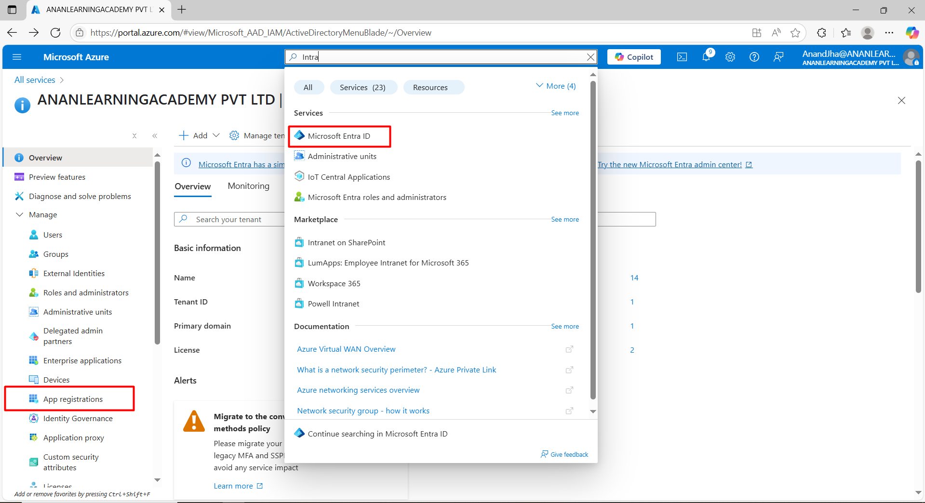

Search for “Microsoft Intra ID” and go to “App Registrations”
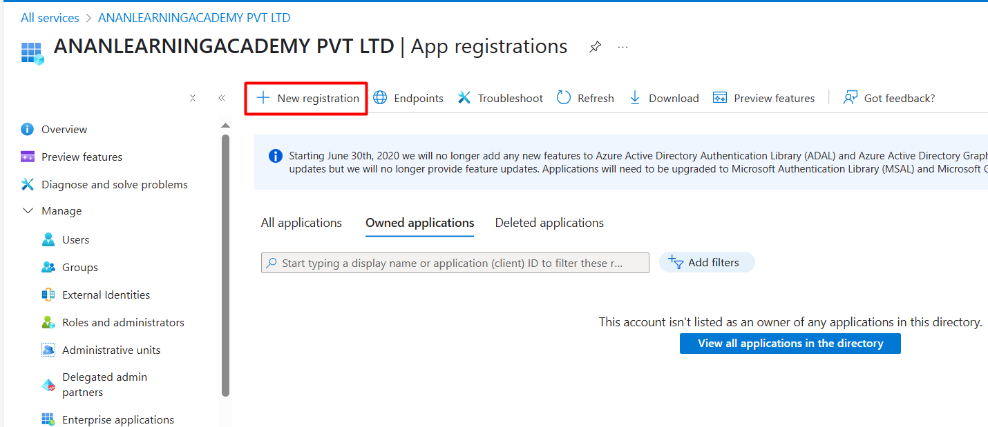

Register the new app.
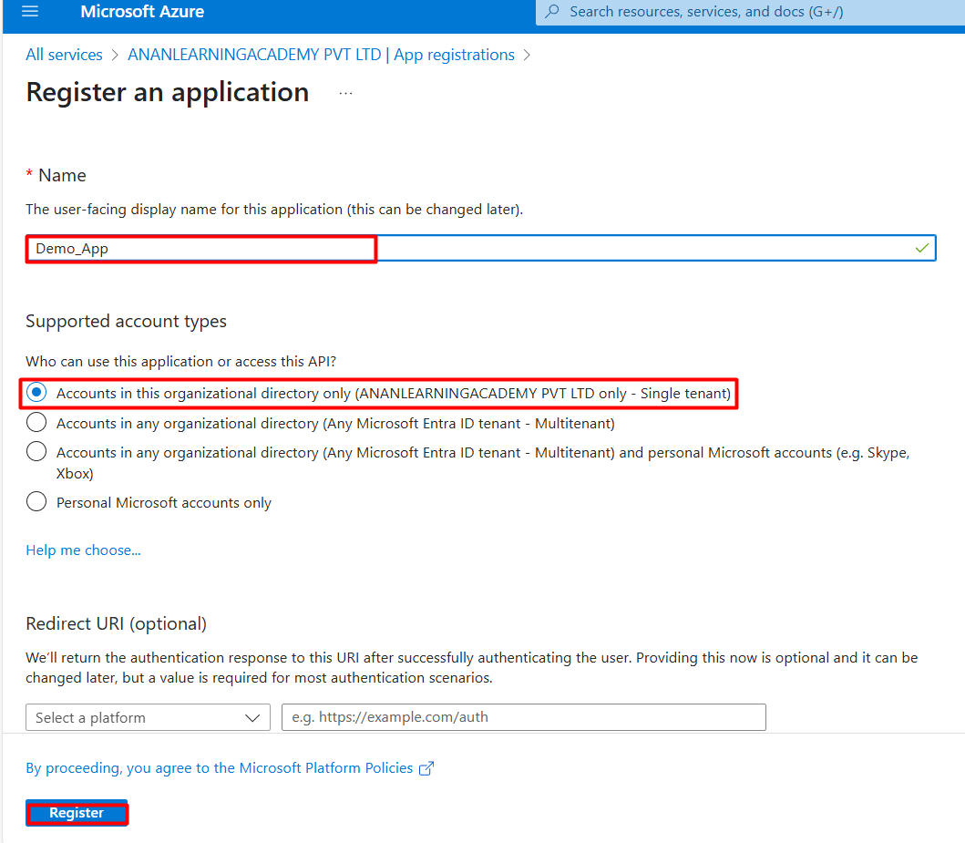

Open the App you have created, Save the Client ID & Tenant ID for the later purpose.
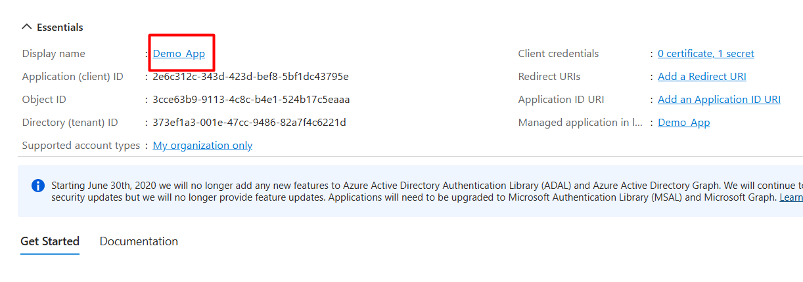
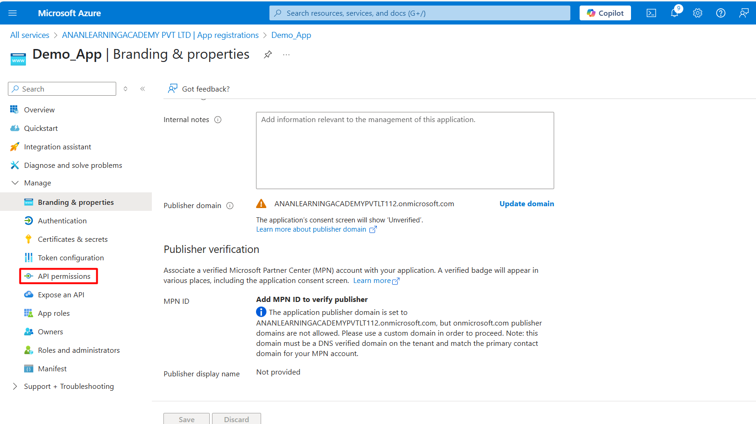

Go to API permissions -> Click on “Add a Permission” -> Choose PowerBI Service -> Delegated Permission -> Tenant
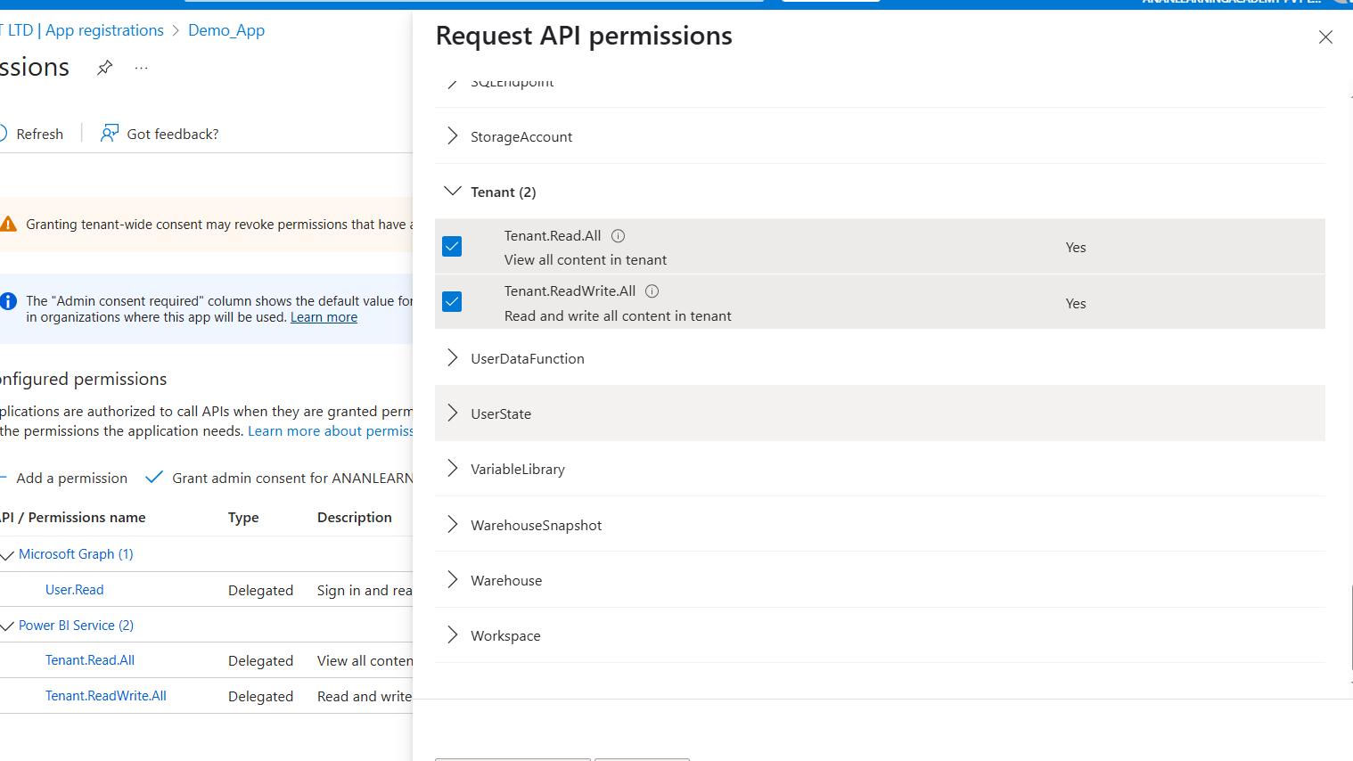

Add Permissions and Grant Admin Consent
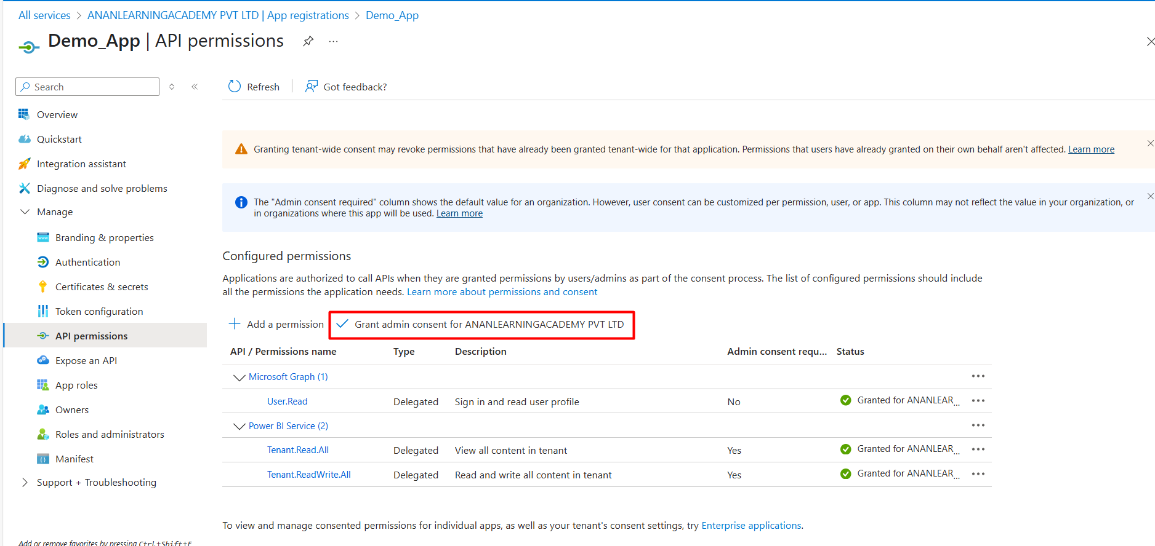

Now create a Secret ID in the app.
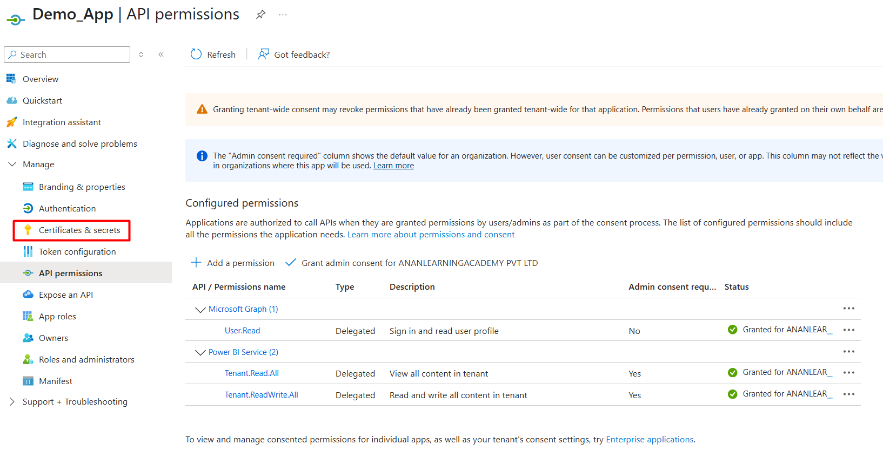
Note: Save the Secret Value somewhere as it will be hidden after sometime.
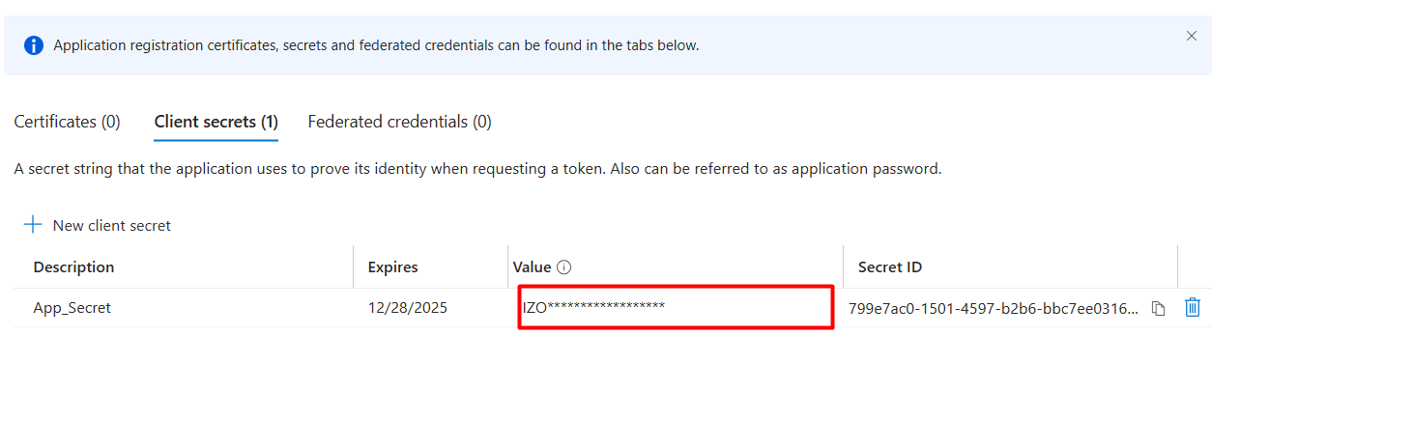

Now go again in the search bar and type “Microsoft Entra ID” and look for the Groups.
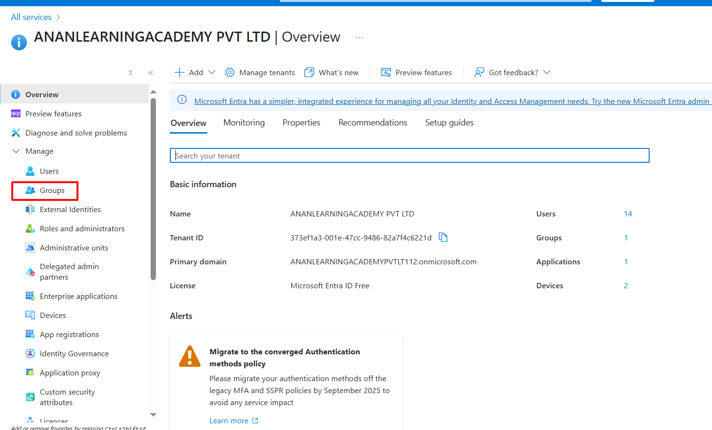

Add a Group and the type should be security. Add yourself as an owner.
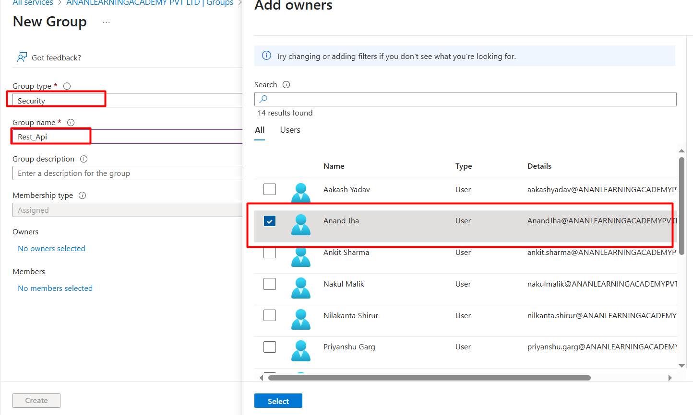

Step 2: Go to Power BI service Admin portal and enable “Service Principals can access read-only admin APIs”. Add the Security Group you have created.
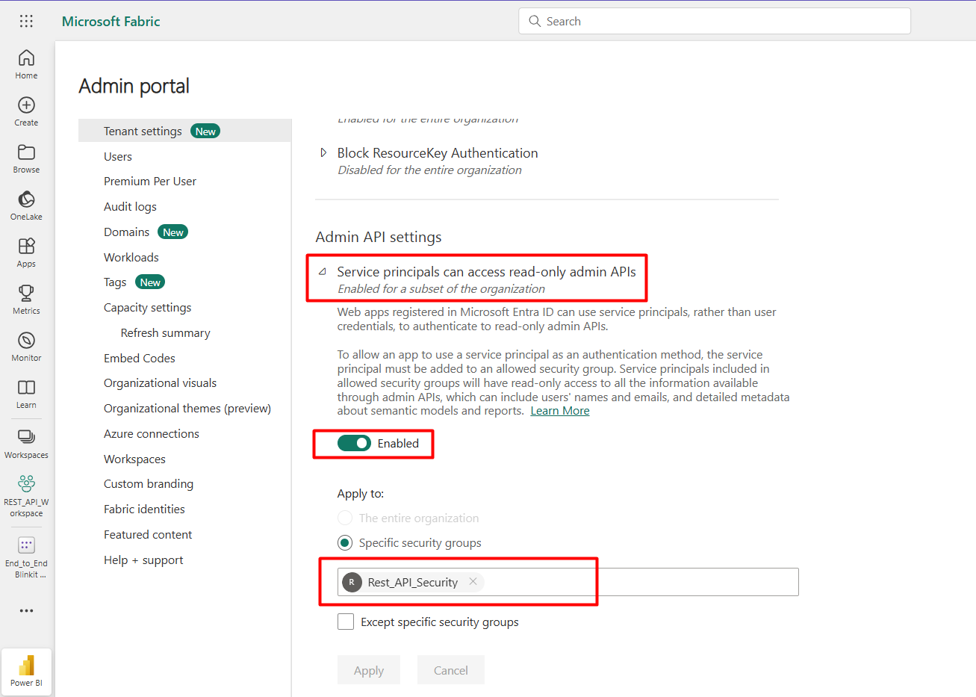
Now Assign the Application to the workspace as Admin or Member.
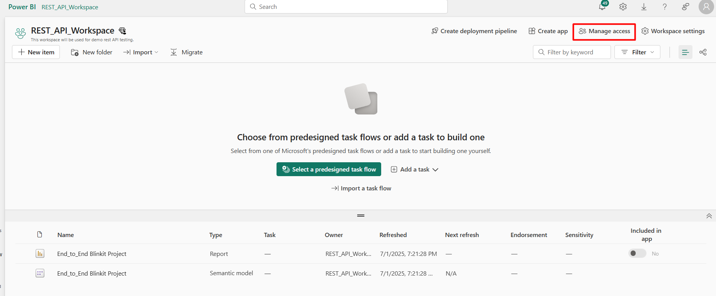
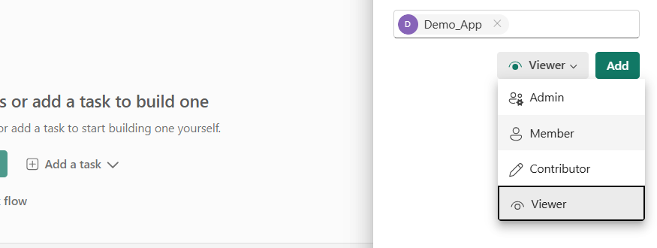

Use this source Code to Trigger the Refresh
import requests
import msal

# Replace with your registered app credentials
client_id = 'Enter your Client ID'
client_secret = 'Enter your Secret ID'
tenant_id = 'Enter your Tenant ID'

def request_access_token():
authority_url = f'https://login.microsoftonline.com/{tenant_id}'
scope = ['https://analysis.windows.net/powerbi/api/.default']

app = msal.ConfidentialClientApplication(
client_id,
authority=authority_url,
client_credential=client_secret
)

token_response = app.acquire_token_for_client(scopes=scope)
if 'access_token' not in token_response:
raise Exception(token_response.get('error_description', 'Unknown error'))

return token_response['access_token']

access_token = request_access_token()

dataset_id = 'Enter Dataset ID'
WorkspaceId = 'Enter Workspace ID'
endpoint = f'https://api.powerbi.com/v1.0/myorg/groups/{WorkspaceId}/datasets/{dataset_id}/refreshes'
headers = {
'Authorization': f'Bearer {access_token}'
}

response = requests.post(endpoint, headers=headers)
if response.status_code == 202:
print('✅ Dataset refresh initiated.')
else:
print('❌ Failed to refresh dataset.')
print(response.status_code, response.reason)
print(response.json())

Getting Report list using Python
Step 1: Get API permissions on Azure Report.ReadWrite.All or Report.Read.All
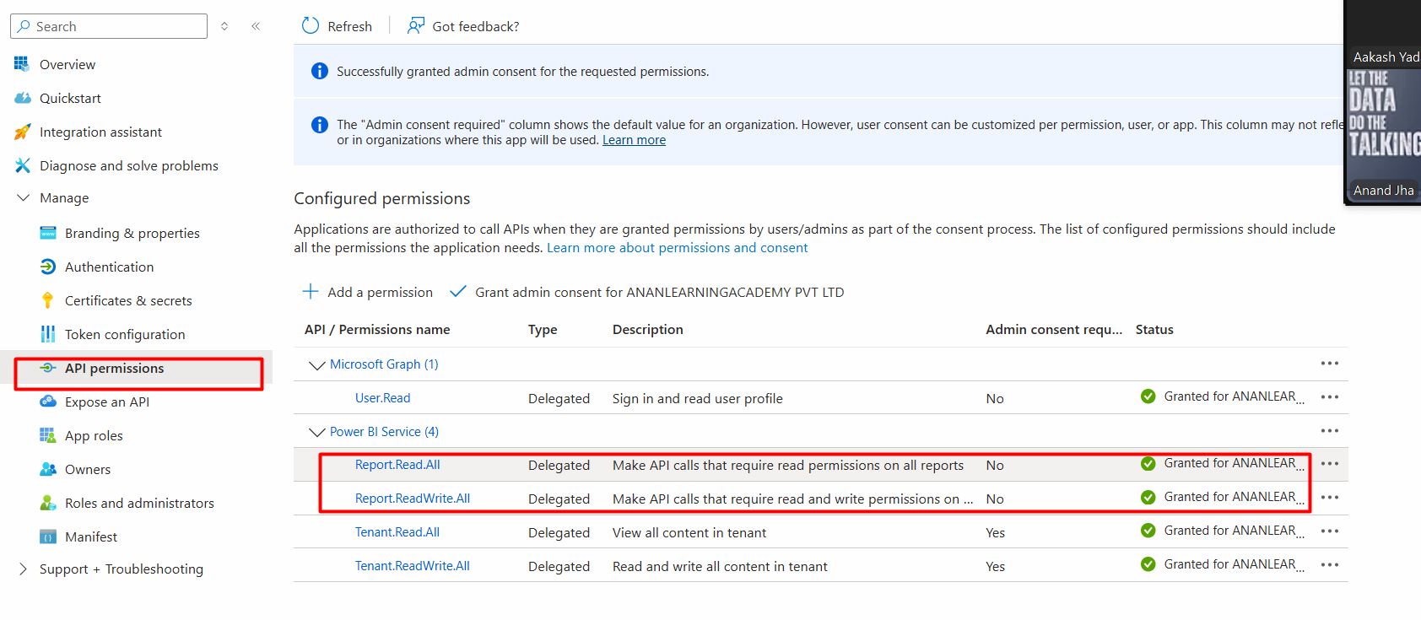

Step 2: Use this source code
import requests
import msal

# Replace with your Azure app details
client_id = 'Enter your Client ID'
client_secret = 'Enter your Secret ID'
tenant_id = 'Enter your Tenant ID'

# Authority and scope
authority_url = f"https://login.microsoftonline.com/{tenant_id}"
scope = ["https://analysis.windows.net/powerbi/api/.default"]

# Initialize MSAL client
app = msal.ConfidentialClientApplication(
client_id,
authority=authority_url,
client_credential=client_secret
)

# Acquire token
result = app.acquire_token_for_client(scopes=scope)
# Workspace ID
groupId = 'b8c8eaa4-f32b-478e-9601-c14b1c59d8fe'

if "access_token" in result:
access_token = result["access_token"]
headers = {
'Authorization': f'Bearer {access_token}',
'Content-Type': 'application/json'
}

# Call Power BI REST API to get list of reports
endpoint = f"https://api.powerbi.com/v1.0/myorg/groups/{groupId}/reports"
response = requests.get(endpoint, headers=headers)
if response.status_code == 200:
reports = response.json().get("value", [])
for report in reports:
print(f"Report Name: {report['name']}")
print(f"Report ID: {report['id']}")
print(f"Web URL: {report['webUrl']}")
print('-' * 40)
else:
print(f"Failed to get reports: {response.status_code} - {response.text}")
else:
print(f"Authentication failed: {result.get('error_description')}")

